DVWA Command Injection — Project Report Template

Title
DVWA — Command Injection Lab
Name: Aashray Lath
Date: 20th September 2025

Short report
Command injection occurs when an application passes unsanitized user input into a system shell, allowing attackers to execute arbitrary OS commands. In this lab I tested DVWA’s Command Injection module (Security = Low) using several payloads and confirmed both direct and blind injection.
First I submitted a basic payload 127.0.0.1; whoami on the Command Injection page; the response included the webserver user www-data, proving remote command execution (see S1_dvwa_basic.png). To demonstrate blind injection I performed a timing-based POST that invoked ping -c 4 127.0.0.1 and compared the elapsed time to a baseline request; the measured difference confirmed execution even when output could be suppressed (see S2_dvwa_blind.png). Finally, I used Burp Repeater to POST an encoded payload (ip=127.0.0.1%26%26id) and captured the server response showing uid=33(www-data) gid=33(www-data), definitive proof of command execution via the application (see S3_dvwa_burp_repeater.png).
On Low security DVWA returns command output directly; on higher security levels the app sanitizes input or suppresses output, requiring encoded payloads or timing techniques to prove execution. Practical mitigations include strict input validation/allow-lists, avoidance of shell invocation (use parameterized APIs or exec functions without a shell), escaping user input, least privilege for web processes, and server-side sandboxing. Removing unsafe functions (system(), popen(), etc.) and using safe libraries for OS interactions substantially reduces this attack surface.

How I tested (Methodology)
- Deployed DVWA locally (Docker) and completed setup (/setup.php → Create/Reset DB).
- Logged in to DVWA (admin / password) and set Security = Low.
- Basic test: navigated to /vulnerabilities/exec/, submitted 127.0.0.1; whoami, observed whoami output in page. (Capture: S1_dvwa_basic.png)
- Blind/timing test: issued a POST with ip=127.0.0.1; ping -c 4 127.0.0.1 and measured elapsed time vs baseline POST to confirm execution by timing. (Capture: S2_dvwa_blind.png)
- Burp evidence: used Burp Repeater to craft/send POST ip=127.0.0.1%26%26id, captured response showing uid=33(www-data) .... Saved raw request/response. (Capture: S3_dvwa_burp_repeater.png, S3_raw_repeater.txt)

Evidence
1) Basic command injection
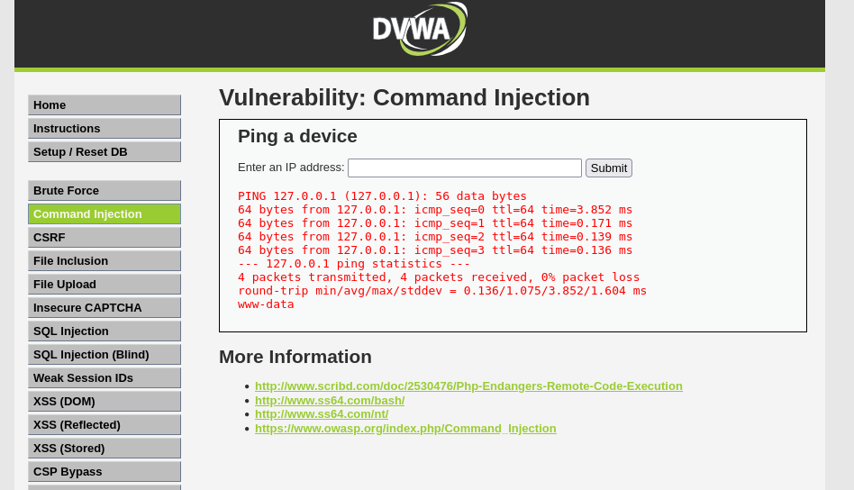
Caption: DVWA Command Injection input 127.0.0.1; whoami and the output showing www-data (proof of direct command execution).

2) Blind / timing test
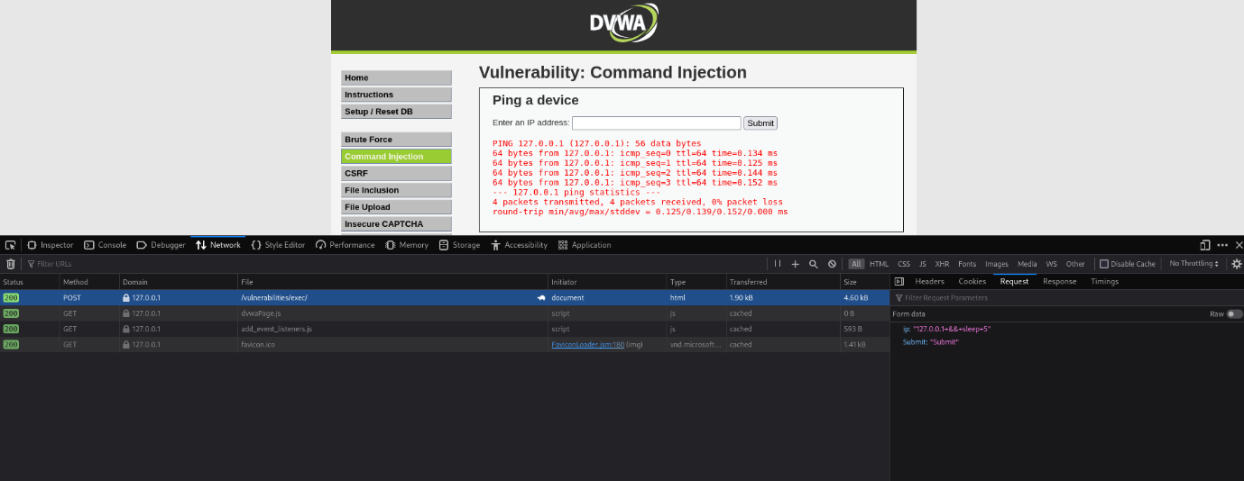
Caption: Timing test (POST ping) showing increased response time vs baseline — proof of blind command execution.

3) Burp Repeater proof
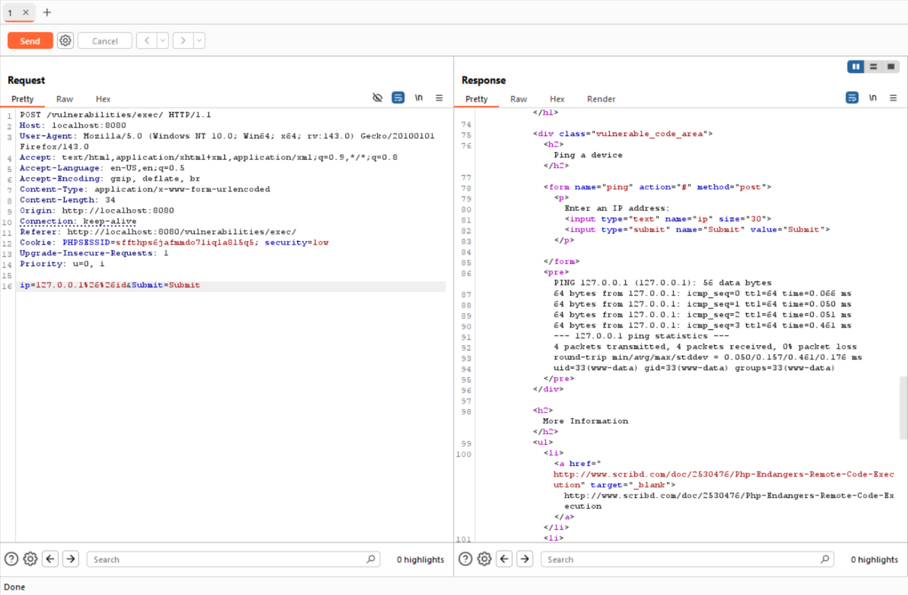
Caption: Burp Repeater request with injected payload ip=127.0.0.1%26%26id (left) and response containing uid=33(www-data) (right) — definitive proof of command execution via the web app.
Include raw request/response as an appendix file: S3_raw_repeater.txt (paste or attach as text).

Reproducibility — exact commands (appendix)
Docker (run DVWA):
docker pull vulnerables/web-dvwa:latest
docker rm -f dvwa 2>/dev/null || true
docker run -d --name dvwa -p 8080:80 vulnerables/web-dvwa:latest
# open http://localhost:8080/setup.php and create/reset DB
Basic test (browser form):
- Open: http://localhost:8080/vulnerabilities/exec/ (login first if required)
- Input: 127.0.0.1; whoami → Submit
Blind timing (POST via curl):
# injected ping (POST)
curl -s -o /dev/null -w "POST_PING_TIME:%{time_total}\n" -X POST \
-d "ip=127.0.0.1; ping -c 4 127.0.0.1" \
"http://localhost:8080/vulnerabilities/exec/"

# baseline (POST)
curl -s -o /dev/null -w "POST_NORMAL_TIME:%{time_total}\n" -X POST \
-d "ip=127.0.0.1" \
"http://localhost:8080/vulnerabilities/exec/"
Burp Repeater (manual request):
POST /vulnerabilities/exec/ HTTP/1.1
Host: localhost:8080
Content-Type: application/x-www-form-urlencoded
Content-Length: 19

ip=127.0.0.1%26%26id

Ethics & cleanup
All testing was performed on a local, intentionally-vulnerable instance of DVWA controlled by the tester. No third-party systems were attacked. After testing, temporary artifacts and any test files should be removed and the environment reset as appropriate.

